344C5
Popa Iulia

Laboratory 1 - CPU Monitoring (Linux)

Task 01. Vmstat
- Used the commands:
stress --cpu $(nproc) and vmstat 1
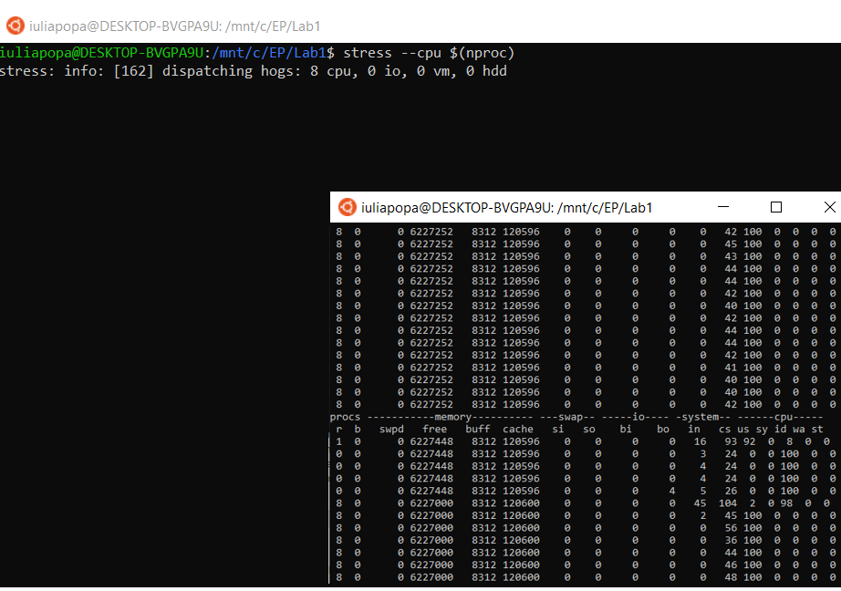
vmstat command shows used memory, procs number, swap pages etc.
- strace vmstat shows system calls made by vmstat
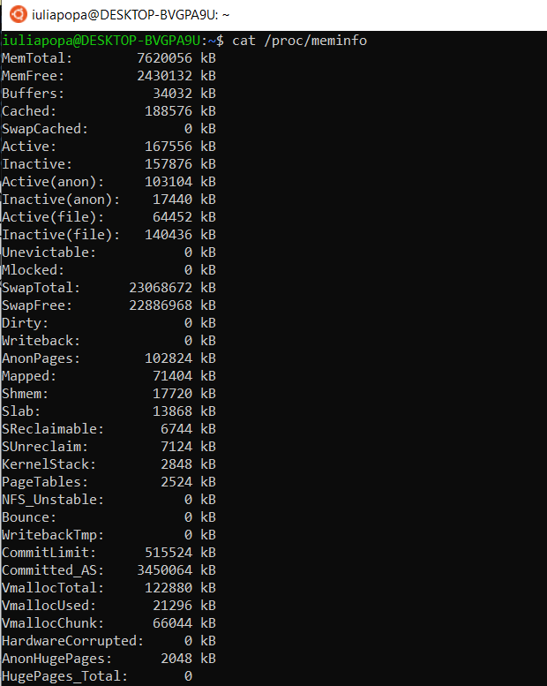

/proc/meminfo file shows memory usage on the system.

- 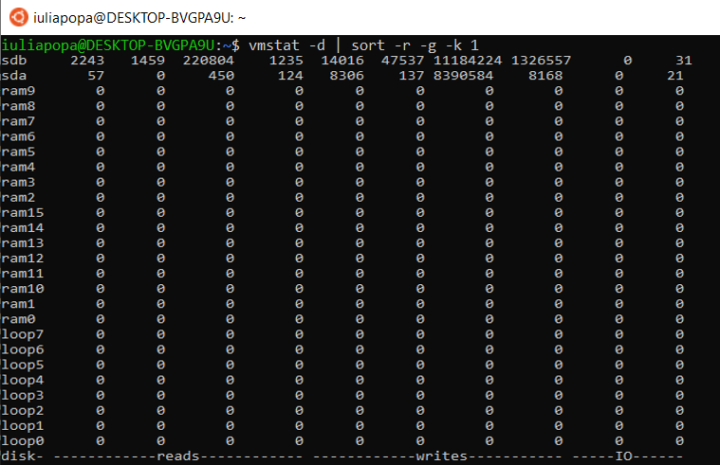
Used the command for decreasing sort by column

Task 02. Mpstat
- 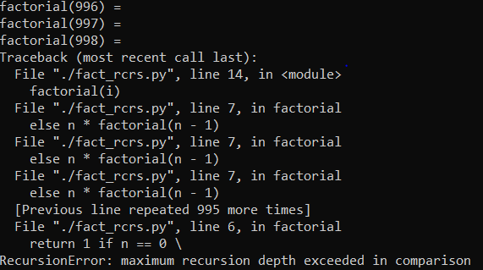
Default recursion limit for Python3 is 1000.
- Set recursion limit with a new value: 10^6, using the command:
sys.setrecursionlimit(10**6)
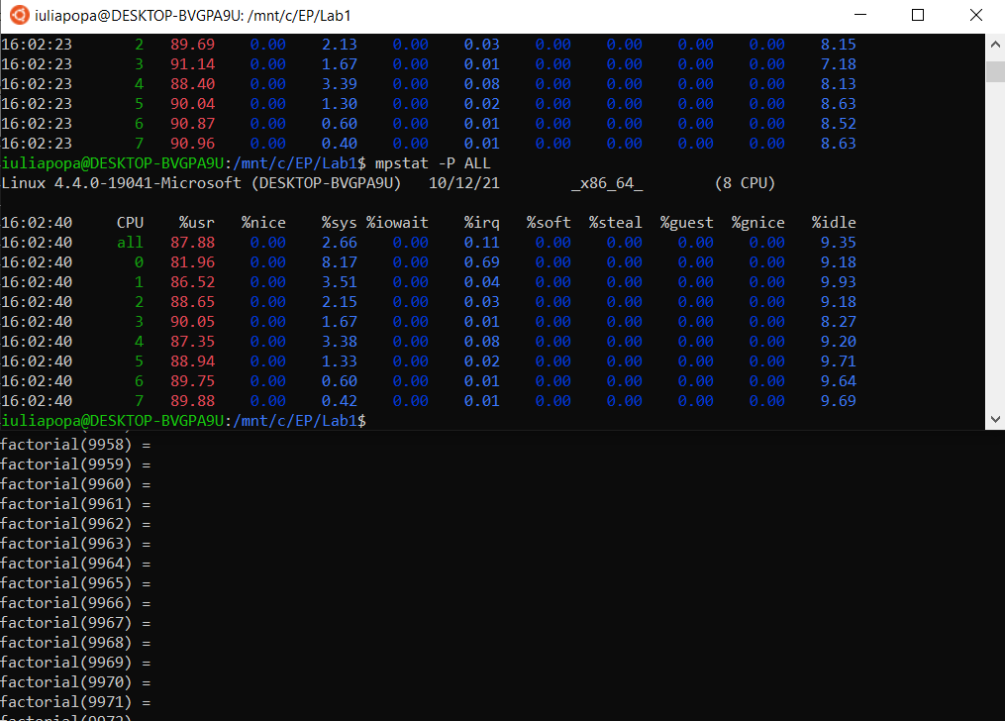

Used stress command shown in picture below:
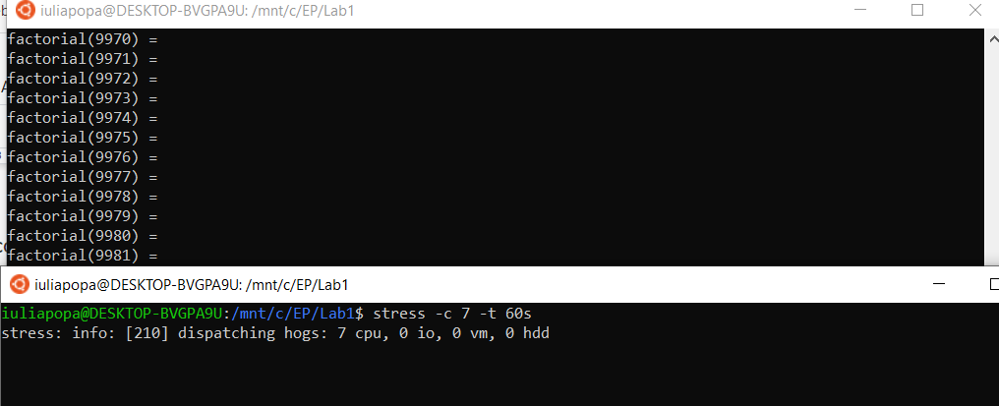
Assigned affinity using the commands:
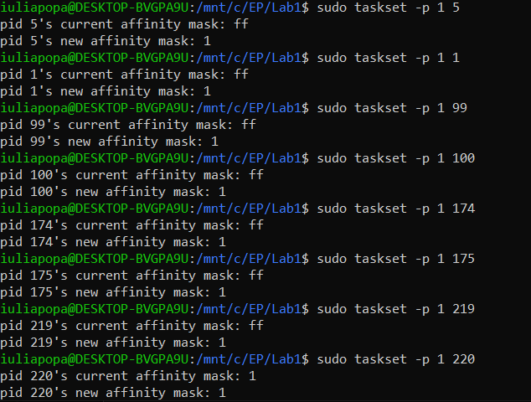

- 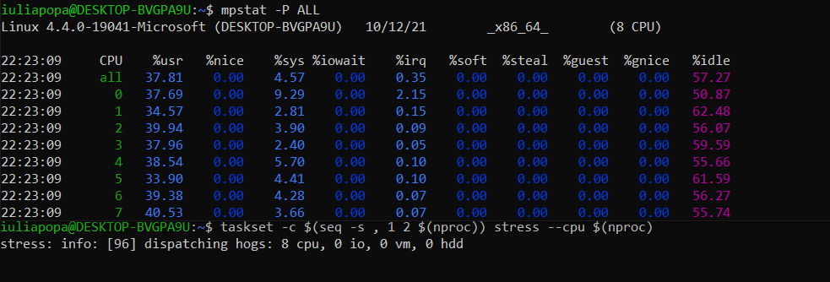
The command above binds CPU stress workers on odd-numbered cores.

Task 03. Zip with compression levels
- 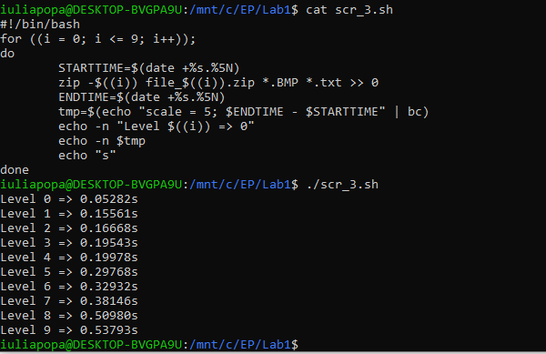
Created script to measure level compression time.
- 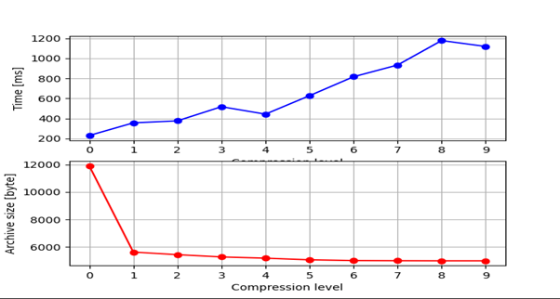
Filled the necessary data and plotted the graph above.

Task 04. Hardware counters
- 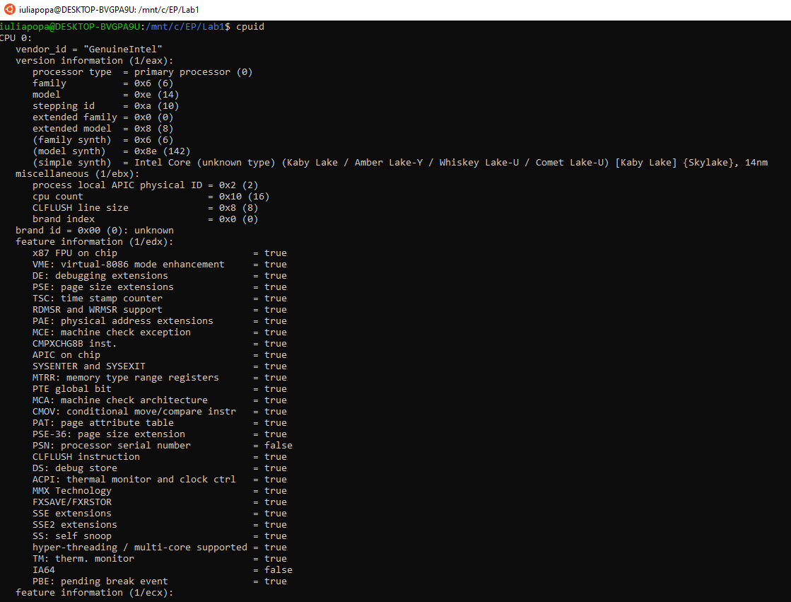
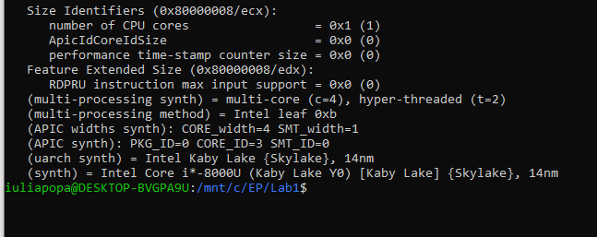
Used the cpuid command.
- C. D. E. - No Linux :(

Task 05. Feedback
Tadaaaaam!
🎉🎉🎉🎉🎉
🎉🎉🎉🎉🎉
🎉🎉🎉🎉🎉
🎉🎉🎉🎉🎉
